**Python MCQ 🡺 Python MCQ - data-flair.training**

<https://data-flair.training/blogs/python-mcq/>

**Q.1. How many CPUs will the threading library use?**

A. Zero. threading does not make use of CPUs.

B. One

C. Two

D. All available CPUs

Answer: B. One

Explanation: threading only uses a single CPU. For running code on different processors, you can use the multiprocessing library.

**Q.2. Which of the following codes raises an exception?**

A. #test

B. a={1, 2, \ #comment 3, 4}

C. a={1, 2, #comment 3, 4}

Answer: B. a={1, 2, \ #comment 3, 4}

The backslash line continuation character should be the last thing in line.

**Q.3. Which of the following follow PEP8?**

Please select 2 correct answers

A. print([2::7])

B. print (“Hello”)

C. groceries = (‘milk’, )

D. print(“Hi”) ; print(“Hello”)

E. scores = {'Ayushi': 97, 'Megha': 98}

Answer: A) E)

B. There should not be space between a function’s name and its parentheses. C. There should not be a space after the element in a tuple with a single element. D. There should not be space before a semicolon.

**Q.4. What will this code print?**



A. 8

B. a+1

C. This code will raise an exception

D. None of the above

Answer: C) This code will raise an exception

This code will raise an exception because you cannot put whitespace before a statement. It raises a SyntaxError for unexpected indent.

**Q.5. What is the maximum value for an integer in Python 3?**

A. 2^63-1

B. 32767

C. 65536

D. No limit

Answer: D) No Limit.

There is no limit on the maximum value of an integer like in Python 2.

**Q.6. How do you denote the end of a block in Python 3?**

A. By indenting the next line less than the current

B. With a semicolon }

C. With the end keyword

D. With a backslash \

Answer: A) By indenting the next line less than the current

Since there are no curly braces in Python, indentation is mandatory

**Q.7. Which of these if-statements work?**

Please select 2 correct answers

A. if i > 7: print(‘Hello’)

B. if i > 7: if i 7: print(‘Hello’) else: print(‘Hi’)

C. print(‘Hello’) if i > 7 else print(‘Hi’)

Answer: A) and C)

B) You cannot put a nested if-statement on the same line as its parent. You cannot put else on the same line as if.

**Q.8. In this list, how will you access the letter ‘t’ in ‘bat’?**



A. list[1, 2, 1, 2]

B. list[2][1][2]

C. list[1][2][1][2]

D. list[1][2][1]

Answer: C) list[1][2][1][2]

‘t’ is at index 2 in the string at index 1 in the list at index 2 in the list at index 1.

**Q.9. How will you turn the list a = [1, 2, 7, 8] into [1, 2, 3, 4, 5, 6, 7, 8]?**

Please select 2 correct answers

A. a[2:2] = [3, 4, 5, 6]

B. a[2:3] = [3, 4, 5, 6, 7]

C. a[2:2] = [3, 4, 5, 6, 7]

D. a[2:3] = [3, 4, 5, 6]

Answer: A) and B)

a[2:2] adds elements between 2 and 7. a[2:3] also replaces 7.

**Q.10. What is the value of y?**



A. 2

B. 5

C. 6

D. This code raises an exception

Answer: C. 6

**Q.11. What is the result of {1, 2, 3} & {4, 5, 6}?**

A. {}

B. set()

C. {1, 2, 3, 4, 5, 6}

D. None of the above

Answer: B. set() =>> Their intersection is an empty set. {} is an empty dictionary, not an empty set.

**Q.12. Which statements delete the value ‘milk’ from the set s = {‘milk’, ‘cheese’, ‘butter’, ‘buttermilk’}?**

Please select 4 correct answers

A. s.discard(‘milk’)

B. del s[‘milk’]

C. s -= ‘milk’

D. s -= {‘milk’}

E. s &= {‘cheese’, ‘butter’, ‘buttermilk’}

F. s.difference_update({‘milk’})

G. s.pop()

Answer: A) D) E) F)

You cannot index a set. You cannot subtract a string from a set, you can subtract a set from a set. pop() will not necessarily remove ‘milk’.

**Q.13. In the following code, how many objects and references does Python create?**



A. One object, one reference

B. One object, two references

C. Two objects, one reference

D. Two objects, two references

Answer: B) One object, two references

There is only one string object ‘Ayushi’ and two references to it. name and fname refer to this object.

**Q.14. According to PEP 8, what case should you use for variable names with more than one word?**

A. Camel case

B. Pascal case

C. Snake case

D. Kebab case

E. Upper case with snake case

Answer: C. Snake case => A variable list style type should be written as list_style_type. This is snake case.

**Q.15. What is the output of the following code?**

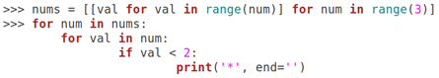

A. *

B. **

C. ***

D. ****

Answer: C. ***

nums is [[], [0], [0, 1]]. We print a star for each value in each sublist if the value is less than 2.

**Q.1. What is the output of this code?**

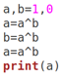

A. 0

B. 1

C. 2

D. This code will raise a runtime error

Answer: A. 0

Explanation: ^ is the XOR operator in Python. In the last statement, a=a^b is a=1^1, which is 0.

**Q.2. What is the value of this expression?**

2**2**3**1

A. 12

B. 64

C. 128

D. 256

Answer: D. 256

Explanation: The ** operator is evaluated right to left. So, 2**2**3**1 is 2**2**3, which is 2**8, which is 256.

**Q.3. Select all the correct statements.**

Please select 3 correct answers

A. You can pass positional arguments in any order.

B. You can pass keyword arguments in any order.

C. You can call a function with positional and keyword arguments.

D. Positional arguments must be before keyword arguments in a function call.

Answer: B, C, D

Explanation: You cannot change the order of positional arguments. A function can take both positional and keyword arguments- positional must be before keyword arguments.

**Q.4. How will you open a file for reading as a text file?**

Please select 2 correct answers

A. open('file.txt')

B. open('file.txt', 'r’)

C. open('file.txt', w’)

D. open('file.txt', 'b’)

Answer: A, B

Explanation: The default mode for opening a file is reading in text mode.

**Q.5. Suppose you have two sets s1 = {1, 2, 3} and s2 = {3, 4, 5}. Which of the following statements give us their union?**

Please select 5 correct answers

A. s1.union({3, 4, 5})

B. s1 | {3, 4, 5}

C. s1.union([3, 4, 5])

D. s1 | [3, 4, 5]

E. s1.union(set([3, 4, 5]))

F. s1 | set([3, 4, 5])

Answer: A, B, C, E, F

Explanation: The union() method can take a list, but the | operator cannot.

**Q.6. Polymorphism is when a subclass can modify the behavior of its superclass.**

A. False

B. True

C. Depends on the contents of the class

D. This is an invalid question

Answer: B) True

**Q.7. What will be the output of the following code?**

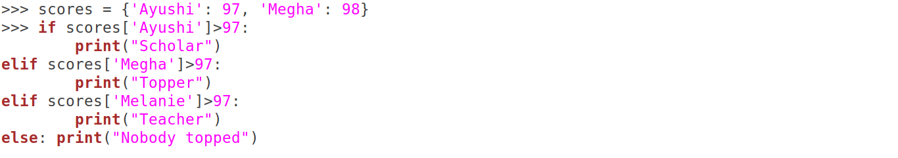A. Scholar B. Topper C. Teacher D. Nobody topped E. This code raises a KeyError

**Answer: B. Topper**

**Q.8. What is the output of the following code?**



A. [‘a’, ‘b’, ‘c’, ‘d’, ‘e’]

B. [‘a’, ‘b’, ‘c’, ‘de’]

C. [‘ade’, ‘bde’, ‘cde’]

D. This raises an exception because we cannot add a string to a list

**Answer: A. [‘a’, ‘b’, ‘c’, ‘d’, ‘e’]**

**Explanation:** list += ‘de’ iterates over ‘de’ and adds ‘d’ and ‘e’ separately to list.

**Q.9. What is the output of the following code?**

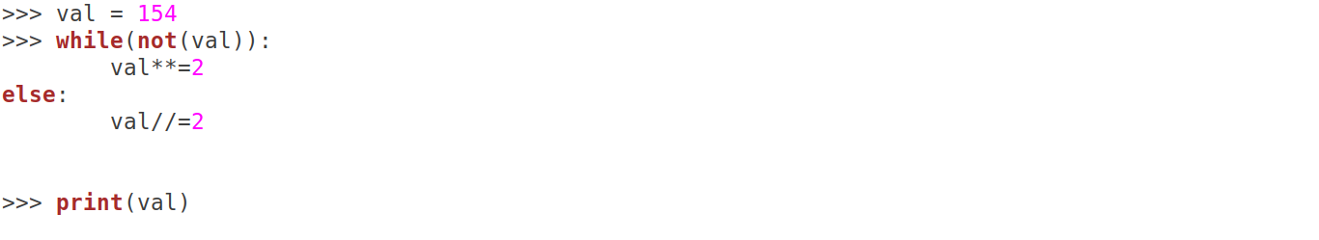A. 77 B. 154 C. 11858 D. 23716 E. This code will raise an exception

Answer: A. 77

**Explanation: The condition for while is False. else is executed and val//=2 makes it 77.**

**Q.10. What will this code print?**

A. Five random numbers in the range 1 to 4

B. Five random numbers in the range 1 to 5

C. Five random integers in the range 1 to 4

D. Five random integers in the range 1 to 5

E. This code raises an exception

**Answer: E. This code raises an exception**

**Explanation: This code gives us a NameError as the name ‘random’ is not defined.**

**Q.11. Choose the correct output for this code:**

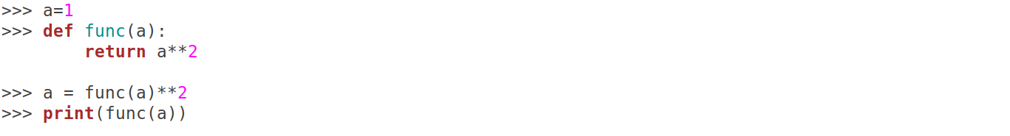A. 1 B. 2 C. 4 D. 16 E. 256

**Answer: A. 1**

**Explanation: 1 raised to the power of anything is 1.**

**Q.12. How many levels deep are sublists in this list?**

A. 1 B. 2 C. 3 D. 4

**Answer: C. 3**

**Explanation: l is [[1, 2, [3, 4]], 5, 6, 7]**

**Q.13. How many stars does this program output?**

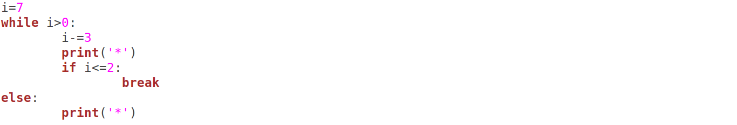A. 1 B. 2 C. 3 D. 4 E. This code will raise an exception

**Answer: B.2**

**Explanation: The else-clause after a while loop does not execute if we break out of the loop.**

**Q.14. Select the incorrect statements:**

I. Constructors cannot return values

II. The __bases__ attribute will give you the names of the direct parent classes

III. issubclass(A, B) returns True if A is an object derived from class B

IV. Function overloading is an effective way to implement polymorphism in Python

A. I and III

B. II and III

C. III and IV

D. I, II and IV

Answer: C. III and IV

**Q.1. What is the output of this code?**

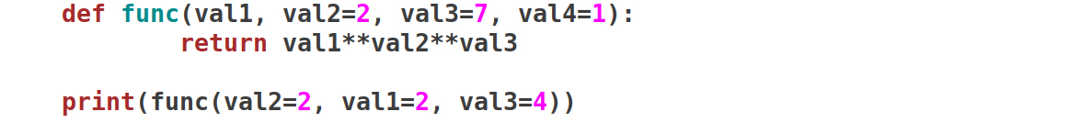

A. 256 B. 32768 C. 65536 D. This code raises an exception

**Answer: C. 65536 =>> We can pass the keyword arguments to func in any order. And ** is evaluated right to left. So, 2**2**4 is 2**16. This is 65536.**

**Q.2. How will you not create a dictionary?**

A. d = {'milk': 50, 'celery': 40}

B. d = dict(milk=50, celery=40)

C. d = dict([ ('milk', 50), ('celery', 40) ])

D. d = { ('milk', 50), ('celery', 40) }

E. d = {} d['milk'] = 50 d['celery'] = 40

**Answer: D. =>> Option D creates a set, not a dictionary.**

**Q.3. In the following code, how will you get to the value 7 ?**

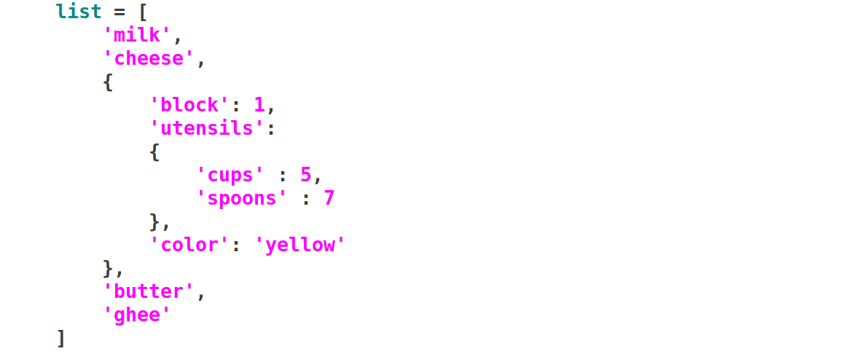

A. list[‘cheese’][‘spoons’]

B. list[2][‘utensils’][‘spoons’]

C. list[‘spoons’]

D. list[‘utensils’][‘spoons’]

**Answer: B. list[2][‘utensils’][‘spoons’]**

**Q.4. Which of these can you use as a dictionary key?**

Please select 3 correct answers

A. ‘key’

B. 'count'

C. [‘1’,’2’]

D. (‘key’, ‘value’)

E. 5j

F. {‘a’:1, ‘b’:2}

**Answer: A, B,D =>> Immutable objects cannot be keys in a dictionary.**

**Q.5. What does the following code print?**



A. True B. False C. This code raises an exception

**Answer: B. False =>> a is not the same as a[:] for a list. They refer to different objects.**

**Q.6. In the following code, what is the output?**



A. 3 B. True C. False D. 1 E. This code will raise an exception

**Answer: A.3 =>> 2 and 3 are non-Boolean operands. The and operator gives the second value because both are truthy.**

**Q.7. Which of the following return True for a string?**

Please select 3 correct answers

A. s[:] == s

B. s[:] is s

C. s[::-1][::-1] == s

D. s[::-1][::-1] is s

**Answer: A, B, C =>> s[:] is a reference to the original string, but s[::-1][::-1] is a reference to a new object.**

**Q.8. What is the value of round(12.5) - round(11.5)?**

A. 0 B. 1 C. 2 D. 3 E. This code will raise an exception

**Answer: A.0 =>> Python uses the round-half-to-even strategy. So, round(12.5) and round(11.5) are 12.**

**Q.9. Select the correct statements:**I. We define classes and functions with the def keyword  
II. A class can define an object  
III. A class can define a function  
IV. A function can define a class

A. II and III

B. III and IV

C. II, III and IV

D. All of them

**Answer: C. II, III and IV =>> We define classes with the class keyword and functions with the def keyword. Classes can define functions and objects. Functions can define classes.**

**Q.10. Select the correct output for this code:**

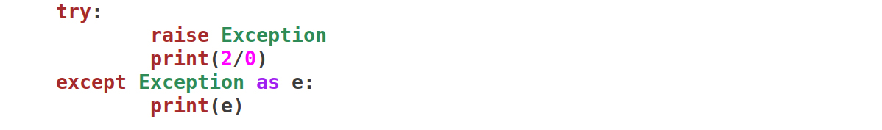

A. Another exception is raised in the except block

B. Exception

C. This code prints a blank line

**Answer: C. This code prints a blank line**

**Q.11. What is the output of this code?**

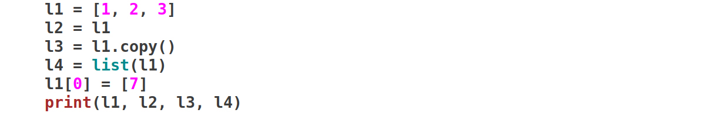

A. [7, 2, 3] [7, 2, 3] [1, 2, 3] [1, 2, 3]

B. [[7], 2, 3] [[7], 2, 3] [[7], 2, 3] [1, 2, 3]

C. [7, 2, 3] [7, 2, 3] [7, 2, 3] [1, 2, 3]

D. [[7], 2, 3] [[7], 2, 3] [1, 2, 3] [1, 2, 3]

**Answer: D. [[7], 2, 3] [[7], 2, 3] [1, 2, 3] [1, 2, 3]**

**l2 is the same object as l1. l3 and l4 are shallow copies of l1. But changing l1 does not change l3 and l4.**

**Q.12. What is the output of this code?**

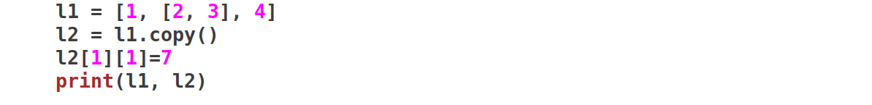

A. [1, [2, 3], 4] [1, [2, 7], 4]

B. [1, [2, 7], 4] [1, [2, 7], 4]

C. [1, [2, 3], 4] [1, [2, 7, 3], 4]

D. [1, [2, 7, 3], 4] [1, [2, 7, 3], 4]

**Answer: B. [1, [2, 7], 4] [1, [2, 7], 4]**

**When we change a sublist in the shallow copy, it changes the original.**

**Q.13. What is the size of an empty tuple in Python?**

A. 0 bytes

B. 8 bytes

C. 32 bytes

D. 48 bytes

**Answer: D. 48 bytes**

**Empty tuples have 48 bytes as overhead size. Also, each element holds 8 bytes.**

**Q.14. What is the output of this code?**

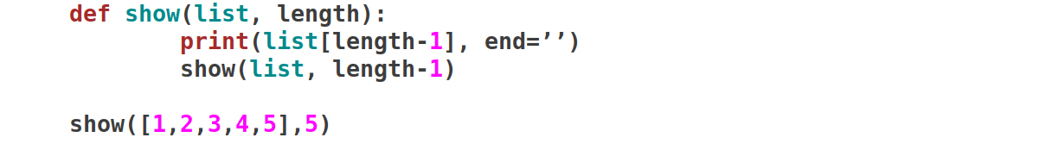

A. 54321

B. 54321IndexError: list index out of range

C. 5432154321

D. 5432154321IndexError: list index out of range

**Answer: D. 5432154321IndexError: list index out of range**

**The program prints for indices 4 to -5, and then raises an IndexError for length=-5.**